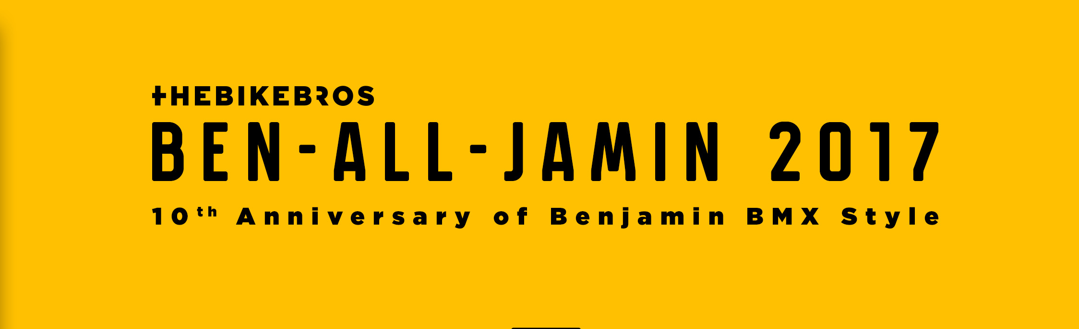
APPLICATION FORM
Name: City:
Surname: State:
Date of Birth: Phone:
Age: Post office:
A few lines about you:

Please fill out the filled in application form and the statement to alex@tbb-bike.cz no later than May 17, 2017

DECLARATION
I, the undersigned .......................................... date of birth. ......... .. ... ....... ... ... ... I declare,
That I will attend the BMX race on 27-28.5.2017 in the Pardubice skatepark at my own responsibility and own risk:
- I will use protectors, helmet, protect property and my own health, other riders and third parties when I move in the park and actively prevent damage to health and property.
- I declare to be in the park at my own risk and responsibility, knowing that the organizer of the event is not responsible for any damage to health or property or for damages and injuries that arise if such damage happens.
Entrants under the age of 18 must have the legal representative's signature / signature!
In Pardubice on 27.5.2017
Handwritten signature: .................................... Signature of legal representative: ....... .............. …

